TOMCAT to deploy the DMS project:

Use Import MAVEN project link in eclipse to load this project

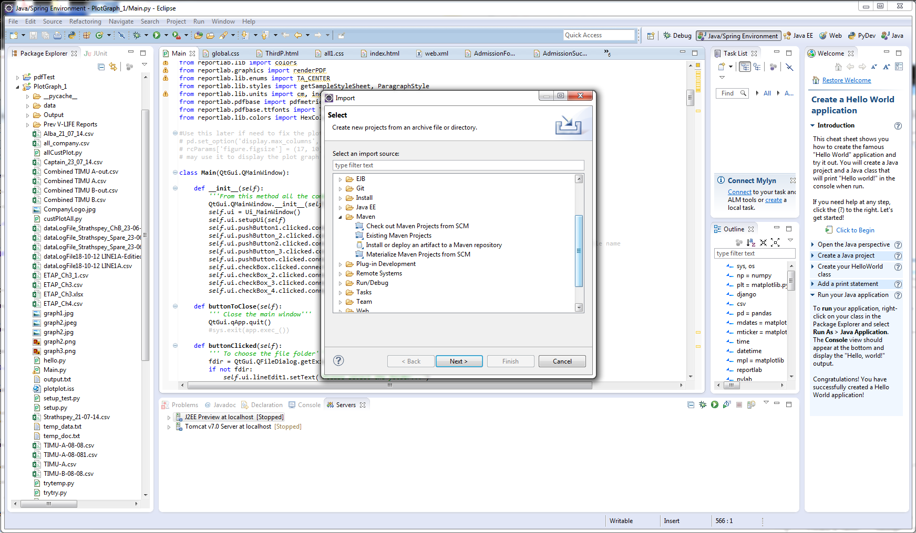

When the option ‘Existing Maven Projects’ is chosen

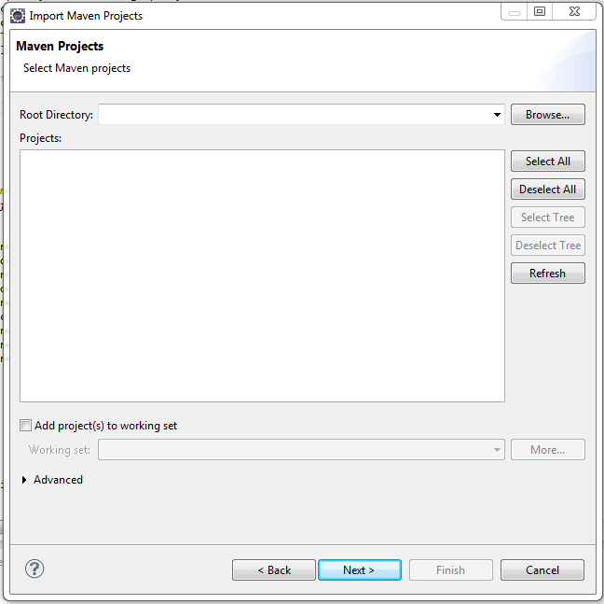

The above screen appears, from the slot ‘Root Directory’ browse for the project

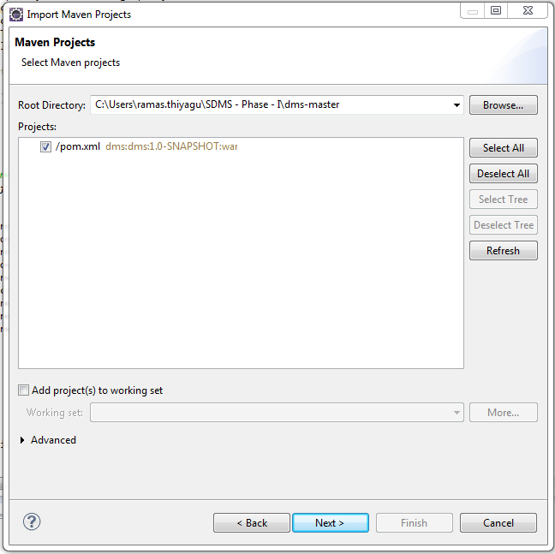

Click next

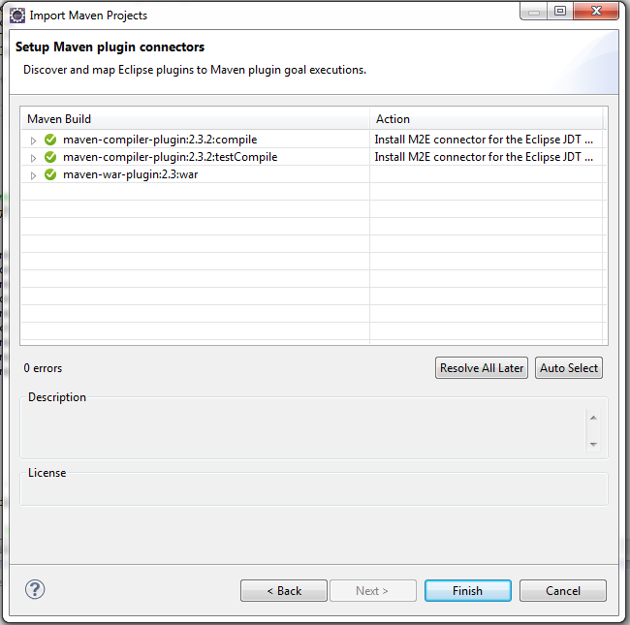

Click finish button

Maven requires ‘M2E connector for the Eclipse JDT compiler’ to install

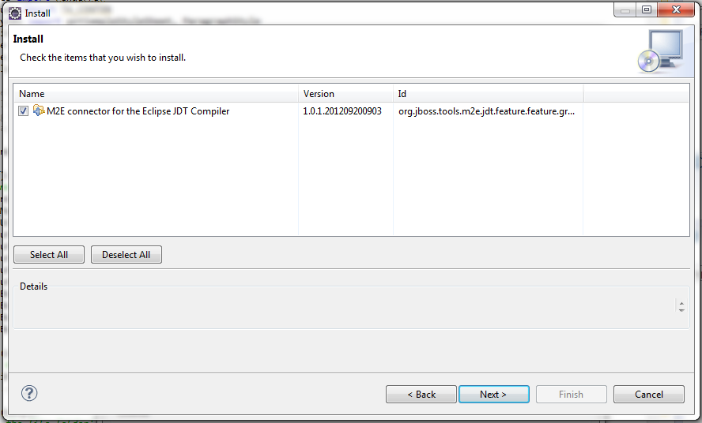

Press next

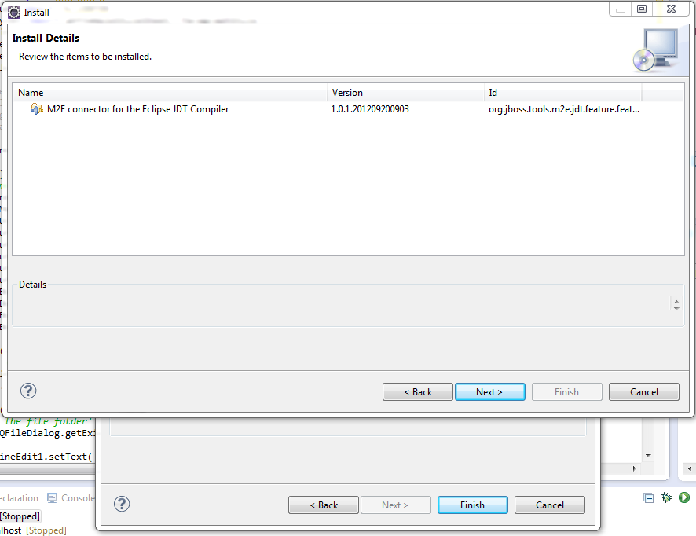

Accept the terms of the license agreement

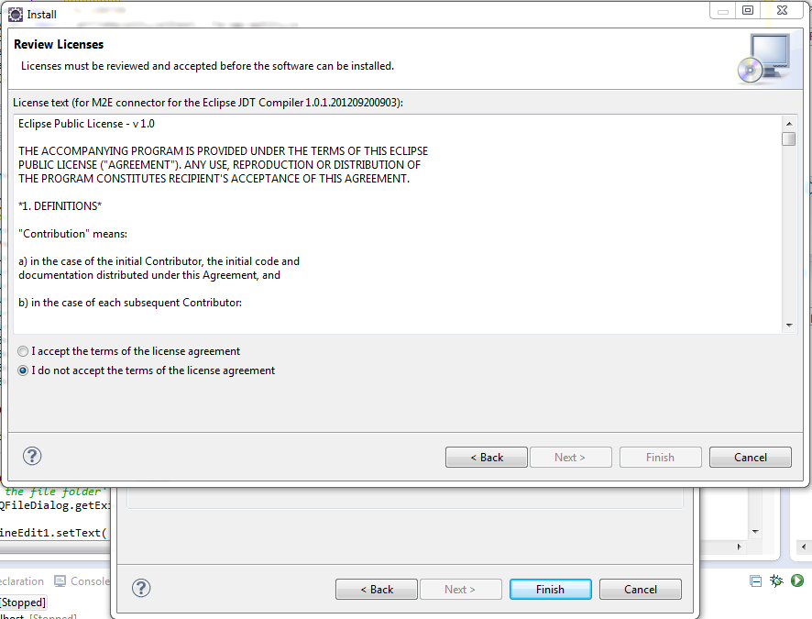

Installing Software

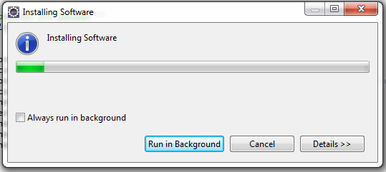

Security warning appeared

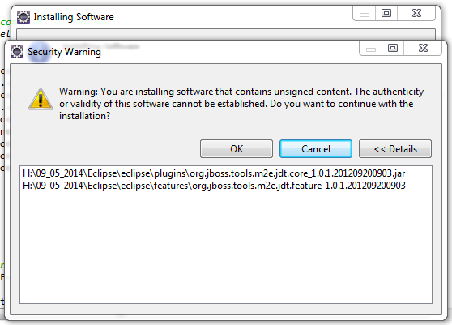

Click ok to continue…

Click Finish to complete…

Eclipse loads the complete project into the environment

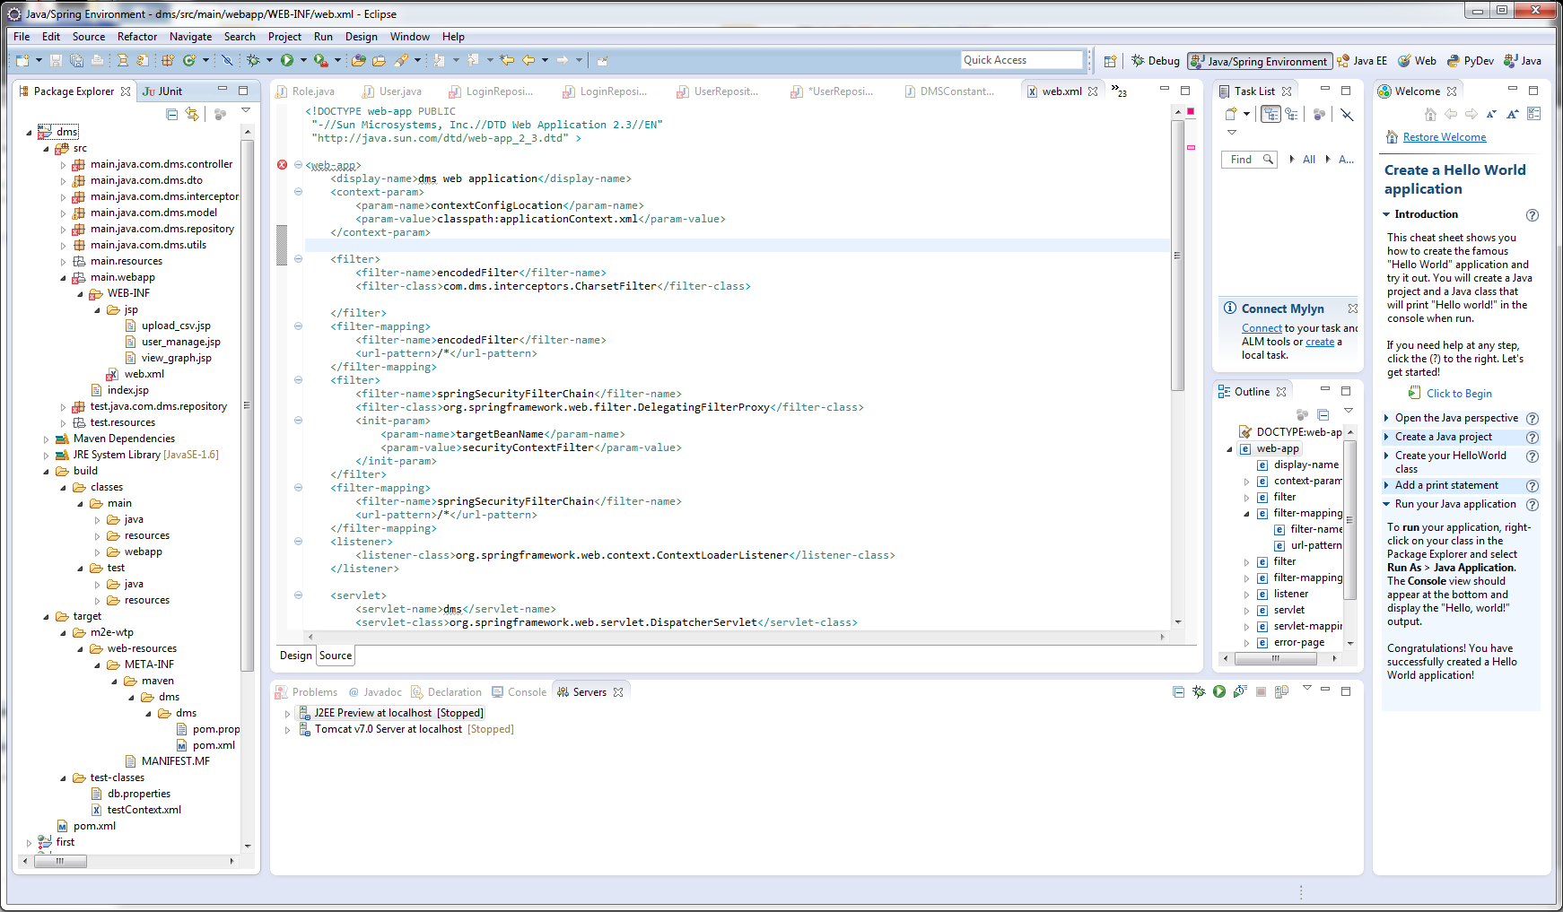

Error: the import com.dms cannot be resolved

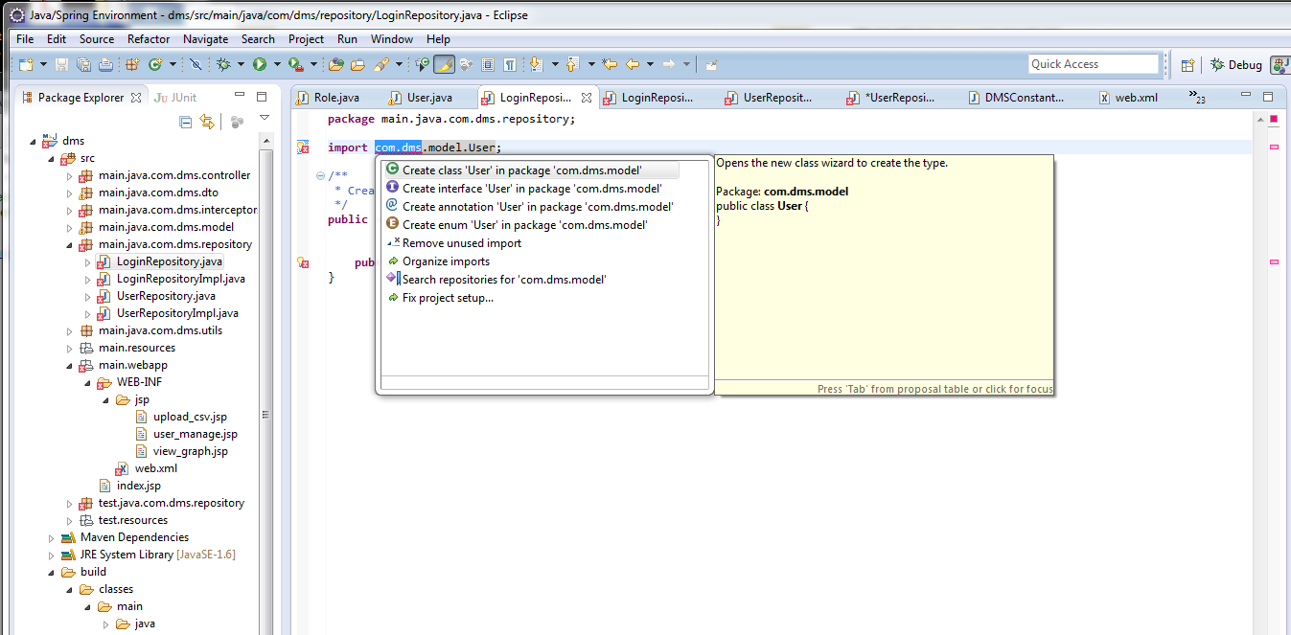

When I change package ->

com.dms.dto

to

main.java.com.dms.dto

Package error is cleared but the

import com.dms.modek.user;

error can’t be cleared, please! advise to fix the error.

Note: when I deploy it, I can’t see the generated dms.war file

After deploy it on the server

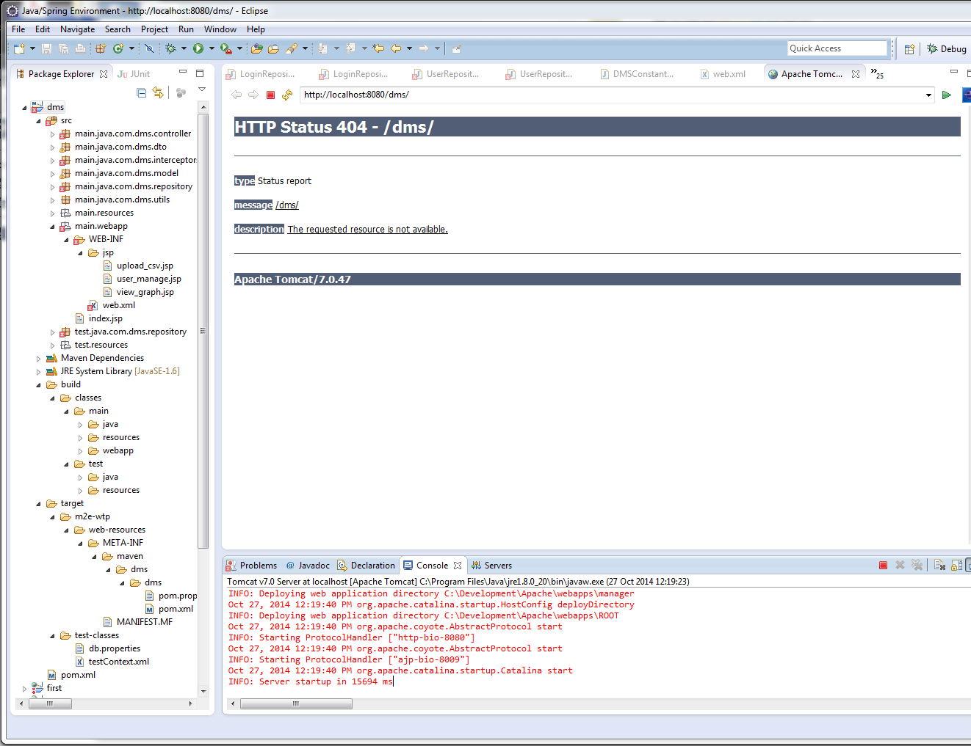

on the browser

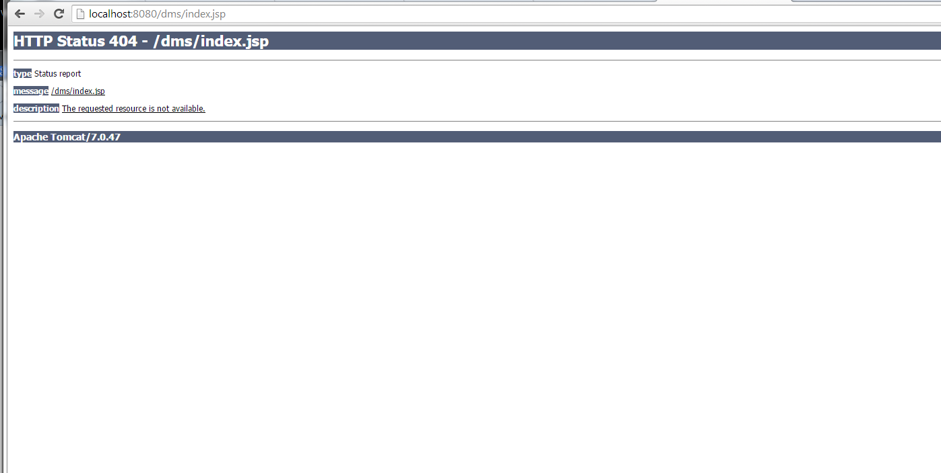

How and where should I create Mysql database with name “dms”